CVE 307: Strength of Materials II (TUTORIAL)
- Define the terms: bending stress in a beam, neutral axis, section modulus, and moment of resistance.
- Where are the top and bottom layers of cantilever beam section subjected to?
- Calculate the maximum stress induced in a cat iron pipe of external diameter 60mm, of internal diameter 40mm and of length 5m when the pipe is supported at its ends and carries a point load of 80N at its centre.
- A rectangular beam 60 mm wide and 150 mm deep is simply supported over a span of 6 m. If the beam is subjected to central point load of 12 kN, find the maximum bending stress induced in the beam section.
- Find the centre of gravity of the L- section shown below.
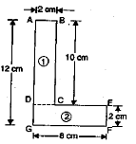
- From bending stresses in simple beams, prove that the relations 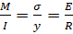
- Where M = Bending moment; I = Moment of Inertial; σ = Bending stress; E = Young’s modulus; and R = Radius of curvature.
- Calculate the shear force and bending moment for the cantilever beam subjected to the loads as shown below, then draw the shear force diagram (SFD) and bending moment diagram (BMD).
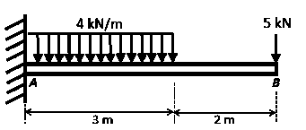
- With the aid of diagram, derive an expression for strain energy stored in a body when the load is gradually applied on the body.
- A steel rod bar is 2m long and 50mm in diameter. An axial pull of 100kN is suddenly applied to the rod. Calculate the instantaneous stress induced and also the instantaneous elongation produced in the rod. Take E = 200 GN/m²

